Finance Project
Student’s Name
Instructor’s Name
Date of Submission

OBJECTIVE
The assignment aims to compute the annualized mean return, the annualized standard deviation of the monthly returns, and the correlation coefficient of the return on the two stocks, TSLA and Apple stocks. Furthermore, the paper builds the portfolio for both TSLA and Apple by obtaining the adjusted monthly closing prices in ten years.
DATA
The adjusted monthly closing prices are from March 09, 2002, to March 09, 2012, the data obtained from finance.yahoo.com website. From the data, the TSLA and Apple’s monthly returns were calculated, together with annualized mean return and annualized standard deviation of the monthly returns. Moreover, the correlation coefficient of the return on the two stocks is also determined. The predetermined weights calculate the standard deviation and annualized mean return and the results tabulated.
RESULTS
 | TSLA | AAPLE
AVERAGE | 0.039466295 | 0.00517689
STANDARD DEVIATION | 0.689943689 | 0.1319
ANNUALIZED MEAN RETURN | 0 | 0.33884087
ANNUAL STANDARD DEVIATION | 0.49982432 | 0.42929388
CORRELATION | 0.293717517

SET OF INVESTMENT OPPORTUNITY
WEIGHT | TSLA | AAPLE | STANDARD DEVIATION | EXPECTED RETURN
 | 1 | 0 | 0.453185527 | 0.43984088
 | 0.9 | 0.1 | 0.427666978 | 0.41328587
 | 0.8 | 0.2 | 0.386027147 | 0.36373086
 | 0.7 | 0.3 | 0.350612392 | 0.34637593
 | 0.6 | 0.4 | 0.227387312 | 0.23862182
 | 0.5 | 0.5 | 0.197844329 | 0.21106598
 | 0.4 | 0.6 | 0.161931517 | 0.19351091
 | 0.3 | 0.7 | 0.123284892 | 0.15585579
 | 0.2 | 0.8 | 0.098340196 | 0.13848078
 | 0.1 | 0.9 | 0.074865726 | 0.09984594
 | 0 | 1 | 0.059982342 | 0.06478974

MINIMUM VARIANCE | TSLA | AAPLE
 | 0.67849925 | 0.52571089
MINIMUM VARIANCE PORTFOLIO | EXPECTED RETURN | STANDARD DEVIATION
 | 0.28953951 | 0.39878795

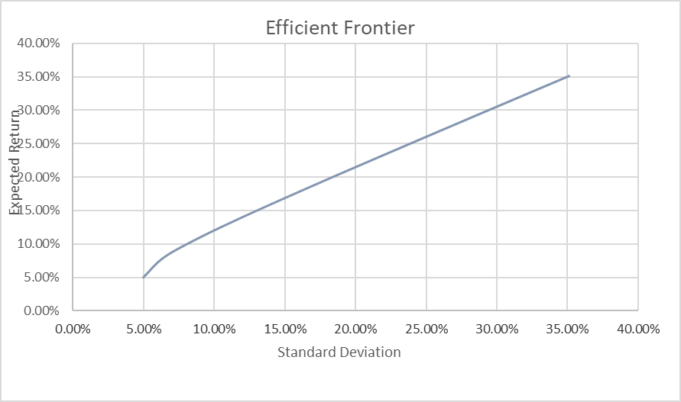
CONCLUSION
TSLA and Apple have a very high coefficient of correlation of 0.5229764. 0.5229764 is closer to +1, and closer to +1 correlation coefficient shows that the two stocks share a relatively strong bond; thus, TSLA and apple share a relatively strong bond. Therefore, if the supply of one company increases, the other company's stock increases, and if the stock of one company performs gravely, the stock of the other company drops as well. The portfolio discussed is suitable to investors who are concerned with supply which have significant tolerance risks.

